https://www.linux.com/learn/intro-systemd-runlevels-and-service-management-commands

Intro to Systemd Runlevels and Service Management Commands
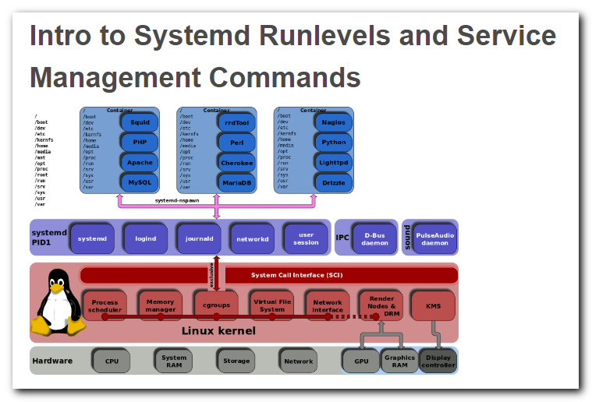
In olden times we had static runlevels. systemd has mechanisms for more flexible and dynamic control of your system.
Before we get into learning more useful systemd commands, let's take a little trip down memory lane. There is this weird dichotomy in Linux-land, where Linux and FOSS are always pushing ahead and progressing, and people are always complaining about it. Which is why I am taking all of this anti-systemd uproar with a grain of salt, because I remember when:
- Packages were evil, because real Linux users built everything from source code and kept strict control of what went on their systems.
- Dependency-resolving package managers were evil, because real Linux users resolved dependency hells manually.
- Except for apt-get, which was always good, so only Yum was evil.
- Because Red Hat was the Microsoft of Linux.
- Yay Ubuntu!
- Boo hiss Ubuntu!
And on and on...as I have said lo so many times before, changes are upsetting. They mess with our workflow, which is no small thing because any disruption has a real productivity cost. But we are still in the infant stage of computing, so it's going to keep changing and advancing rapidly for a long time. I'm sure you know people who are stuck in the mindset that once you buy something, like a wrench or a piece of furniture or a pink flamingo lawn ornament, it is forever. These are the people who are still running Windows Vista, or deity help us Windows 95 on some ancient, feeble PC with a CRT monitor, and who don't understand why you keep bugging them to replace it. It still works, right?
Which reminds me of my greatest triumph in keeping an old computer running long after it should have been retired. Once upon a time a friend had this little old 286 running some ancient version of MS-DOS. She used it for a few basic tasks like appointments, diary, and a little old accounting program that I wrote in BASIC for her check register. Who cares about security updates, right? It's not connected to any network. So from time to time I replaced the occasional failed resistor or capacitor, power supply, and CMOS battery. It just kept going. Her tiny old amber CRT monitor grew dimmer and dimmer, and finally it died after 20+ years of service. Now she is using an old Thinkpad running Linux for the same tasks.
If there is a moral to this tangent it escapes me, so let's get busy with systemd.

Runlevels vs. States
SysVInit uses static runlevels to create different states to boot into, and most distros use five:
- Single-user mode
- Multi-user mode without network services started
- Multi-user mode with network services started
- System shutdown
- System reboot.
Me, I don't see a lot of practical value in having multiple runlevels, but there they are. Instead of runlevels, systemd allows you to create different states, which gives you a flexible mechanism for creating different configurations to boot into. These states are composed of multiple unit files bundled into targets. Targets have nice descriptive names instead of numbers. Unit files control services, devices, sockets, and mounts. You can see what these look like by examining the prefab targets that come with systemd, for example /usr/lib/systemd/system/graphical.target, which is the default on CentOS 7:
[Unit]
Description=Graphical Interface
Documentation=man:systemd.special(7)
Requires=multi-user.target
After=multi-user.target
Conflicts=rescue.target
Wants=display-manager.service
AllowIsolate=yes
[Install]
Alias=default.target

So what do unit files look like? Let us peer into one. Unit files are in two directories:
- /etc/systemd/system/
- /usr/lib/systemd/system/
The first one is for us to play with, and the second one is where packages install unit files. /etc/systemd/system/ takes precedence over /usr/lib/systemd/system/. Hurrah, human over machine. This is the unit file for the Apache Web server:
[Unit]
Description=The Apache HTTP Server
After=network.target remote-fs.target nss-lookup.target
[Service]
Type=notify
EnvironmentFile=/etc/sysconfig/httpd
ExecStart=/usr/sbin/httpd/ $OPTIONS -DFOREGROUND
ExecReload=/usr/sbin/httpd $OPTIONS -k graceful
ExecStop=/bin/kill -WINCH ${MAINPID}
KillSignal=SIGCONT
PrivateTmp=true
[Install]
WantedBy=multi.user.target
These files are fairly understandable even for systemd newcomers, and unit files are quite a bit simpler than a SysVInit init file, as this snippet from /etc/init.d/apache2 shows:
SCRIPTNAME="${0##*/}"
SCRIPTNAME="${SCRIPTNAME##[KS][0-9][0-9]}"
if [ -n "$APACHE_CONFDIR" ] ; then
if [ "${APACHE_CONFDIR##/etc/apache2-}" != "${APACHE_CONFDIR}" ] ; then
DIR_SUFFIX="${APACHE_CONFDIR##/etc/apache2-}"
else
DIR_SUFFIX=
The whole file is 410 lines.
You can view unit dependencies, and it's always surprising to me how complex they are:
$ systemctl list-dependencies httpd.service

cgroups
cgroups, or control groups, have been present in the Linux kernel for some years, but have not been used very much until systemd. The kernel documentation says: "Control Groups provide a mechanism for aggregating/partitioning sets of tasks, and all their future children, into hierarchical groups with specialized behaviour." In other words, it has the potential to control, limit, and allocate resources in multiple useful ways. systemd uses cgroups, and you can see them. This displays your entire cgroup tree:
$ systemd-cgls
You can generate a different view with the good old ps command:
$ ps xawf -eo pid,user,cgroup,args

Useful Commands
This command reloads the configuration file of a daemon, and not its systemd service file. Use this when you make a configuration change and want to activate it with least disruption, like this example for Apache:
# systemctl reload httpd.service
Reloading a service file completely stops and then restarts a service. If it is not running this starts it:
# systemctl restart httpd.service
You can restart all daemons with one command. This reloads all unit files, and re-creates the whole systemd dependency tree:
# systemctl daemon-reload
You can reboot, suspend, and poweroff as an ordinary unprivileged user:
$ systemctl reboot
$ systemctl suspend
$ systemctl poweroff

As always, there is much, much more to learn about systemd. Here We Go Again, Another Linux Init: Intro to systemd and Understanding and Using Systemd are good introductions to systemd, with links to more detailed resources.

https://www.linux.com/learn/here-we-go-again-another-linux-init-intro-systemd

Here We Go Again, Another Linux Init: Intro to systemd
In the days of yore we had a System V (SysV) type init daemon to manage Linux system startup, and it was good. It was configured with simple text files easily understood by mortals, and it was a friendly constant amid the roiling seas of change. Then came systemd, and once again we Linux users were cast adrift in uncharted waters. Why all this change? Can't Linux hold still for just a minute?

Ch Ch Ch Changes
Linux has been contentedly using sysvinit (System V initialization) to manage system startups for ever so many years now, except for distributions like Slackware that use the BSD-style init. SysV and BSD init are similar enough that it's easy to use either one without a lot of fuss.
Then came two new init systems for Linux: Ubuntu's Upstart, first released in 2006, and systemd, born in 2009. The systemd code was written primarily by Leonard Poettering. Upstart has been the default in Ubuntu since 6.10 Edgy Eft and is available in most distros. systemd is the default init in Fedora 15 and later, and is also in most distro repos for anyone who wants to try it on their favorite Linux.
Overhauling key subsystems tends to give users the jitters, because it means being forced to learn new ways to administer our systems and changing our workflow, and the prospects of essential services suffering growing pains and being less-than-reliable aren't happy-making. So what's with this new systemd thingy, and what benefits does it bring to us mere Linux users?

Faster Startups
The purpose of sysvinit is to launch userspace. At boot the kernel launches PID 1, the very first process to run at startup. (Run the pstree command to see a nice artistic ASCII diagram of your process tree.) It used to be that the BIOS and sysvinit were equal offenders in dragging boot times out to a minute or more. Both have speeded up, but sysvinit is always going to be slow because it starts processes one at a time, performs dependency checks on each one, and waits for daemons to start so more daemons can start.
So why not start processes in parallel? There is a way to do this without all kinds of complexities, and that is to take advantage of the way Unix-type daemons work. Clients of Unix daemons don't need to know if the daemons they depend on are actually running — all they need is the correct Unix domain sockets to be available. What the heck are these sockets? They are inter-process communication sockets (IPC), and they are how processes on the local system talk to each other. You can see these with netstat:

$ netstat -a --protocol=unix
Active UNIX domain sockets (only servers)
Proto RefCnt Flags Type State I-Node Path
unix 2 [ ACC ] STREAM LISTENING 4836 /var/run/dbus/system_bus_socket
unix 9 [ ] DGRAM 4584 /dev/log
unix 3 [ ] STREAM CONNECTED 489456 /tmp/orbit-carla/linc-
aaa-0-476044c676da9
unix 3 [ ] STREAM CONNECTED 489455
unix 3 [ ] STREAM CONNECTED 489452 /tmp/orbit-carla/
linc-8ba-0-45fe9270a46b2
[...]

As you can see the sockets have inodes, following the tradition of "everything in Unix is a file." So you can perform various operations on them with standard Linux file utilities, which is a fun topic for another day.
So all sockets for all daemons can be created in one step, and then all daemons in a second step. Any client requests for daemons that are not yet running will be cached in the socket buffer, and then filled when the daemons are up and running. I'm no kernel hacker so maybe I'm too easily impressed, but this seems like an ingenious and efficient use of something that has been around for decades, and preferable to trying to invent something brand-new.

Hotplugging and On-Demand Services
sysvinit has a static configuration and launches processes one at a time, in order. When we configure sysvinit we've always had to be mindful of launching them in the correct order, like remembering to start networking before starting network services. And we have to be mindful that everything we might need is launched at startup, or else we will have to start it manually, because after startup sysvinit goes to sleep and doesn't do any more.
This might be adequate for simple servers, but not for desktop and mobile systems. Users roam among different networks, attach and remove all manner of devices like keyboards and headsets, audio interfaces, storage media, movies and music — thanks to Bluetooth and USB we finally have universal plug-in ports, and hotplugging devices is routine instead of an exotic adventure. Remember how, way back in olden times, we were warned to never hotplug PS/2 keyboards, mice, or IDE drives because of the risk of physical damage? Even if nothing got fried they were detected only at boot.
Auto-detecting and auto-mounting removable devices has gone through a lot of stages in Linux. Remember the fun old days of manually mounting and unmounting CDs and USB sticks? And making fun of Windows and Mac refugees who thought that was weird and dumb? Well, it was weird and dumb. But Linux was still a baby, so we had to deal with it.
Then there are network services that could be on-demand like file shares, printers, VNC, SSH, and so on. The bottom line is in these modern times way more stuff happens after startup, so instead of trying to anticipate everything you might need and start it all at boot, why not build a system that launches and stops processes on demand? As an everyday practical matter this seems to address one of my pet peeves, and that is how many distros launch Avahi and the Bluetooth daemons at startup. I have no use for either, so I always disable them. A small matter to be sure, but I like the idea of the computer handling these sorts of chores because I have real work to do.
There have been a lot of attempts at subsystems to manage dynamic handling of hardware and software: HAL (hardware abstraction layer), autofs, devfs, and all kinds of other ones I've forgotten. Now we have D-Bus for advanced inter-process communications and management, such as process lifecycle management. D-Bus uses Unix domain sockets as its transport mechanism, and it seems to be here to stay (for example, KDE and Gnome run on D-Bus). So with the extra functionality in D-Bus it seems a natural expansion of duties for systemd, as PID 1, to function as the full-time Linux process babysitter, and bring the efficiencies of parallelization and dynamic resource management to a running system, rather than simply starting the system and then going to sleep until the next reboot.
This a bare introduction to the intricacies of systemd and Linux process management. The systemd home page is a great starting point to learn more. Come back next week to learn how to manage and debug systemd on your own systems.

https://www.linux.com/learn/understanding-and-using-systemd

Understanding and Using Systemd
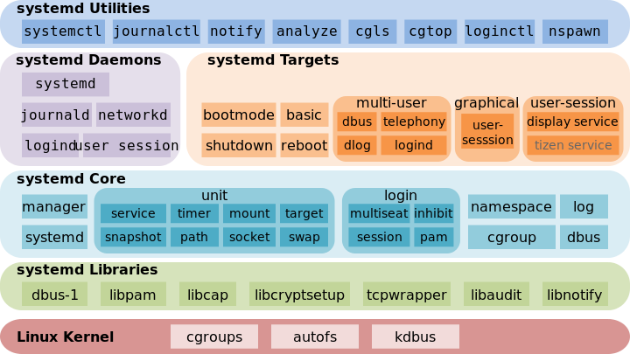
Like it or not, systemd is here to stay, so we might as well know what to do with it.
systemd is controversial for several reasons: It's a replacement for something that a lot of Linux users don't think needs to be replaced, and the antics of the systemd developers have not won hearts and minds. But rather the opposite, as evidenced in this famous LKML thread where Linus Torvalds banned systemd dev Kay Sievers from the Linux kernel.
It's tempting to let personalities get in the way. As fun as it is to rant and rail and emit colorful epithets, it's beside the point. For lo so many years Linux was content with SysVInit and BSD init. Then came add-on service managers like the service and chkconfig commands. Which were supposed to make service management easier, but for me were just more things to learn that didn't make the tasks any easier, but rather more cluttery.
Then came Upstart and systemd, with all kinds of convoluted addons to maintain SysVInit compatibility. Which is a nice thing to do, but good luck understanding it. Now Upstart is being retired in favor of systemd, probably in Ubuntu 14.10, and you'll find a ton of systemd libs and tools in 14.04. Just for giggles, look at the list of files in the systemd-services package in Ubuntu 14.04:
$ dpkg -L systemd-services
Check out the man pages to see what all of this stuff does.
It's always scary when developers start monkeying around with key Linux subsystems, because we're pretty much stuck with whatever they foist on us. If we don't like a particular software application, or desktop environment, or command there are multiple alternatives and it is easy to use something else. But essential subsystems have deep hooks in the kernel, all manner of management scripts, and software package dependencies, so replacing one is not a trivial task.
So the moral is things change, computers are inevitably getting more complex, and it all works out in the end. Or not, but absent the ability to shape events to our own liking we have to deal with it.

First systemd Steps
Red Hat is the inventor and primary booster of systemd, so the best distros for playing with it are Red Hat Enterprise Linux, RHEL clones like CentOS and Scientific Linux, and of course good ole Fedora Linux, which always ships with the latest, greatest, and bleeding-edgiest. My examples are from CentOS 7.
Experienced RH users can still use service and chkconfig in RH 7, but it's long past time to dump them in favor of native systemd utilities. systemd has outpaced them, and service and chkconfig do not support native systemd services.
Our beloved /etc/inittab is no more. Instead, we have a /etc/systemd/system/ directory chock-full of symlinks to files in /usr/lib/systemd/system/. /usr/lib/systemd/system/ contains init scripts; to start a service at boot it must be linked to /etc/systemd/system/. The systemctl command does this for you when you enable a new service, like this example for ClamAV:
# systemctl enable clamd@scan.service
ln -s '/usr/lib/systemd/system/clamd@scan.service''/etc/systemd/system/multi-user.target.wants/clamd@scan.service'
How do you know the name of the init script, and where does it come from? On Centos7 they're broken out into separate packages. Many servers (for example Apache) have not caught up tosystemd and do not have systemd init scripts. ClamAV offers both systemd and SysVInit init scripts, so you can install the one you prefer:
$ yum search clamav
clamav-server-sysvinit.noarch
clamav-server-systemd.noarch
So what's inside these init scripts? We can see for ourselves:
$ less /usr/lib/systemd/system/clamd@scan.service
.include /lib/systemd/system/clamd@.service
[Unit]
Description = Generic clamav scanner daemon
[Install]
WantedBy = multi-user.target
Now you can see how systemctl knows where to install the symlink, and this init script also includes a dependency on another service, clamd@.service.
systemctl displays the status of all installed services that have init scripts:
$ systemctl list-unit-files --type=service
UNIT FILE STATE
[...]
chronyd.service enabled
clamd@.service static
clamd@scan.service disabled
There are three possible states for a service: enabled or disabled, and static. Enabled means it has a symlink in a .wants directory. Disabled means it does not. Static means the service is missing the [Install] section in its init script, so you cannot enable or disable it. Static services are usually dependencies of other services, and are controlled automatically. You can see this in the ClamAV example, as clamd@.service is a dependency of clamd@scan.service, and it runs only when clamd@scan.service runs.
None of these states tell you if a service is running. The ps command will tell you, or use systemctl to get more detailed information:
$ systemctl status bluetooth.service
bluetooth.service - Bluetooth service
Loaded: loaded (/usr/lib.systemd/system/bluetooth.service; enabled)
Active: active (running) since Thu 2014-09-14 6:40:11 PDT
Main PID: 4964 (bluetoothd)
CGroup: /system.slice/bluetooth.service
|_4964 /usr/bin/bluetoothd -n
systemctl tells you everything you want to know, if you know how to ask.

Cheatsheet
These are the commands you're probably going to use the most:
# systemctl start [name.service]
# systemctl stop [name.service]
# systemctl restart [name.service]
# systemctl reload [name.service]
$ systemctl status [name.service]
# systemctl is-active [name.service]
$ systemctl list-units --type service --all
systemd has 12 unit types. .service is system services, and when you're running any of the above commands you can leave off the .service extension, because systemd assumes a service unit if you don't specify something else. The other unit types are:

- Target: group of units
- Automount: filesystem auto-mountpoint
- Device: kernel device names, which you can see in sysfs and udev
- Mount: filesystem mountpoint
- Path: file or directory
- Scope: external processes not started by systemd
- Slice: a management unit of processes
- Snapshot: systemd saved state
- Socket: IPC (inter-process communication) socket
- Swap: swap file
- Timer: systemd timer.

It is unlikely that you'll ever need to do anything to these other units, but it's good to know they exist and what they're for. You can look at them:
$ systemctl list-units --type [unit name]

Blame Game
For whatever reason, it seems that the proponents of SysVInit replacements are obsessed with boot times. My systemd systems, like CentOS 7, don't boot up all that much faster than the others. It's not something I particularly care about in any case, since most boot speed measurements only measure reaching the login prompt, and not how long it takes for the system to completely start and be usable. Microsoft Windows has long been the champion offender in this regards, reaching a login prompt fairly quickly, and then taking several more minutes to load and run nagware, commercialware, spyware, and pretty much everything except what you want. (I swear if I see one more stupid Oracle Java updater nag screen I am going to turn violent.)
Even so, for anyone who does care about boot times you can run a command to see how long every program and service takes to start up:
$ systemd-analyze blame
5.728s firewalld.service
5.111s plymouth-quit-wait.service
4.046s tuned.service
3.550s accounts.daemon.service
[...]
And several dozens more. Well that's all for today, folks. systemd is already a hugely complex beast; consult the References section to learn more.

References
Freedesktop.org systemd System and Service Manager
Here We Go Again, Another Linux Init: Intro to systemd

